

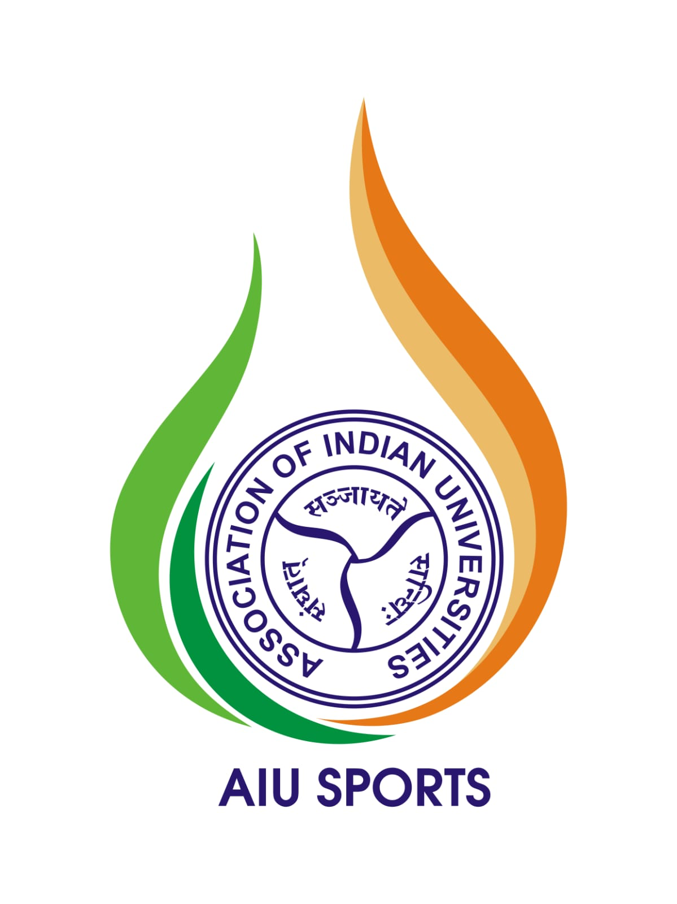

Somaiya Vidyavihar University to Bring the 2026 FISU World University Championship Squash to India in Collaboration with AIU
Student-athletes from 14 countries will compete in Mumbai from August 3–9, as India stages a defining moment for University Squash ahead of the sport's Olympic debut
Team India's six-member squad draws from Somaiya Vidyavihar University, University of Madras and SRM University, reflecting the growing depth of university-level sport across the country
MUMBAI, India, July 22, 2026: India will host the 2026 FISU World University Championship Squash at Somaiya Vidyavihar University in August. This brings together student-athletes from across the world for a week of international competition on Indian soil. Organised in collaboration with the Association of Indian Universities (AIU) under the aegis of the International University Sports Federation (FISU), the championship carries the motto "Smashing Barriers, Uniting Nations." The tournament arrives at a defining moment for the sport, as squash prepares for its historic Olympic debut at the Los Angeles 2028 Games.
India's role as host reflects a trajectory built over successive editions. At the 2023 FISU World University Games in Chengdu, Indian athletes delivered their best-ever performance, winning a record 26 medals. This achievement was recognised by the Honourable Prime Minister Narendra Modi, who personally congratulated the contingent. In 2026, Somaiya Vidyavihar University is taking its commitment to university sport further by hosting the Championship and financially supporting India’s entire six-member squash contingent, as they prepare to represent the country on the world stage.
Participating countries for the 2026 FISU WUC include:

- Singapore - Singapore University Sports Council
- Hong Kong, China - University Sports Federation of Hong Kong, China
- Czech Republic - Czech University Sports Association
- France - Fédération Française du Sport Universitaire
- Spain - Spanish University Sports Committee
- Hungary - Hungarian University Sports Federation
- New Zealand - University and Tertiary Sport New Zealand
- United Kingdom - British Universities and Colleges Sport
- Brazil - Brazil University Sports Confederation
- Switzerland - Swiss University Sports
- Poland - University Sports Association of Poland
- South Africa - University Sport South Africa
- China - China Students Sports Federation (Federation of Chinese University and School Sports, China)
- India - Association of Indian Universities
For the student-athletes competing in Mumbai, the championship is a stage to test themselves against the world's best university players and take a step toward future elite competition. The championship is held across five World Squash Federation (WSF) - certified courts, turning the campus into the global home of university squash for the week. One8 has partnered with us as the official India jersey partner for the championship.
India will field a six-member contingent, with three student-athletes from Somaiya Vidyavihar University representing the host country on home courts: Suraj Chand, Om Semwal and Nirupama Dubey, competing alongside Sandesh P. R and Pooja Arthi from the University of Madras, and Shameena Riaz from SRM University. Our own Suraj Chand will also represent India at the 2026 Asian Games in Japan for the mixed doubles squash event.
Years of Investment, One Global Stage
Somaiya Vidyavihar University being entrusted as host venue is the culmination of years of sustained investment by the Somaiya ecosystem in university sport. Over time, the university has developed its squash infrastructure into a WSF-standard facility, hosted the All India National Inter-University Squash Tournament on four occasions, and emerged as the official training base for the Indian national university squash team, not to mention the Somaiya players who emerged as winners.
Dr (Mrs) Pankaj Mittal, Secretary General, Association of Indian Universities, said: "The Association of Indian Universities is proud to support Somaiya Vidyavihar University, Mumbai, as it hosts the FISU World University Squash Championship 2026 with the International University Sports Federation (FISU). This landmark championship reflects India's growing stature in international university sports and stands as a testimony to the visionary leadership and unwavering commitment of the Government of India towards youth empowerment and sporting excellence. I express my sincere gratitude to the Hon'ble Minister of Youth Affairs & Sports, Government of India, for the continued encouragement and support extended towards the development of university sports and the promotion of young sporting talent at national and international levels. I wish all participants great success and hope the championship becomes a celebration of excellence, unity, and the indomitable spirit of youth."
Matthias Remund, FISU Secretary General and CEO, said, “We are very pleased that FISU World University Championship Squash is returning to India. I am confident that the Association of Indian Universities and Somaiya Vidyavihar University will organise an attractive, unique and unforgettable event that will play an important role in the development of the university sports movement in India and beyond.”
Samir Somaiya, Chancellor, Somaiya Vidyavihar University, said, "Ever since my student days playing squash at Cornell, I have believed that world-class sporting infrastructure should be an integral part of the university ecosystem. Hosting the FISU World University Championship in Mumbai is a significant milestone in realising that vision. At Somaiya, we regard sports as a fundamental pillar of holistic education and are committed to creating an ecosystem that nurtures excellence both on and off the field. Our efforts extend beyond developing world-class facilities on campus to building sustainable pathways that identify, nurture, and empower young sporting talent, from our university courts to rural communities across the country."
Prof Ajay Kapoor, Vice Chancellor, Somaiya Vidyavihar University, echoes the sentiment. "We are honoured that the International University Sports Federation (FISU) and the Association of Indian Universities (AIU) have entrusted Somaiya Vidyavihar University with organising and hosting the 2026 FISU World University Championship Squash. This championship is the result of our shared commitment to advance university sport as a platform for excellence, international collaboration and cultural exchange. We look forward to welcoming student-athletes, officials and delegates from around the world to Mumbai and delivering an experience that reflects the spirit and values of university sport."
Aazaz Khan, Director, Somaiya Sports Academy, said, "Bringing this championship to our courts is the result of years of disciplined preparation. Our players have trained against international-standard competition, our coaches have built systems that produce results, and our facilities meet the benchmark this event demands. That readiness is what August will put on display."
Building the Future of University Sport
Beyond the competition itself, the championship reflects Somaiya Vidyavihar University's long-standing sporting culture and broader vision of integrating sport with higher education. The University has consistently invested in sporting infrastructure, athlete development and opportunities that enable student-athletes to compete at national and international levels. This commitment extends beyond supporting its own athletes to strengthening the wider university sporting ecosystem in India. While academic excellence and high-performance sport have often evolved along separate paths in India, the university believes both can thrive within the same ecosystem when supported by the right infrastructure, coaching and institutional commitment. The championship will also serve as a live learning platform, with students contributing to tournament operations and gaining first-hand experience of hosting an international sporting event.
That commitment also extends beyond the university campus. Guided by its values of inclusion and accessibility, the Somaiya ecosystem is working to expand access to squash by introducing courts across its rural schools, creating opportunities for young athletes who may otherwise never encounter the sport.
When the final point is played in August, the championship will leave behind more than medals and match results. It will strengthen India's position on the global university sports map, inspire the next generation of student-athletes, and reaffirm Somaiya Vidyavihar University's commitment to building an ecosystem where education and sport develop together.
You are cordially invited to the Opening Ceremony of the Championship on 2nd August, 6.30pm onwards at Somaiya Vidyavihar University, Mumbai.
More details on the championship can be found on https://squash2026.fisu.net/ and do not forget to catch FISU World University Championship Squash streamed live on www.worlduniversity.sport
https://www.youtube.com/@FISUtv
https://prasarbharati.gov.in/live-tv/
https://www.wavespb.com/
https://www.youtube.com/@IndiaSquash

—- Ends—-

About FISU

Since its founding in 1949, the International University Sports Federation is the key driver to expand the role and reach of university sport around the world. FISU serves as the global platform for world university sport at all levels through sport events, educational initiatives and wellbeing. Together with its members and continental organisations, FISU supports students, connects universities and leads cultural exchange. FISU fosters academic-athletic balance and promotes wellbeing, respect, excellence and inclusion for generations to come. www.fisu.net

About Association of Indian Universities AIU

The Association of Indian Universities (AIU) is the apex National Sports Promotion Organization (NSPO) for university sports in India and one of the largest associations of universities in the world, representing 1,200+ member universities. For over nine decades, AIU has played a pivotal role in promoting university sports, identifying grassroots sporting talent, and providing a structured pathway for student-athletes to excel at the national and international levels.

As the country's largest organized university sports ecosystem, AIU conducts 230+ Inter-University Tournaments annually across 58 sports disciplines at the zonal and national levels. Through the active participation of 1,100+ universities, 47,000+ affiliated colleges, and 25,000+ colleges in inter-collegiate competitions, AIU provides competitive opportunities to more than 2.2 million student-athletes from a base of over one crore college students.

AIU serves as the primary feeder system for India's national and international multi-sport events by nurturing emerging talent, fostering excellence in sports, and strengthening the university sports movement across the country. In collaboration with its member universities, AIU continues to create opportunities for student-athletes to represent India with distinction on global sporting platforms. aiu.ac.in

About Somaiya Vidyavihar University
Somaiya Vidyavihar University (Accredited with an A Grade by NAAC), established in 2019, is a leading multidisciplinary university in India, built upon the 84-year legacy of Somaiya Vidyavihar. Its approach to education is centred on पेशा (profession), सोच (mindset), and चरित्र (character), preparing students to excel in their chosen fields while empowering them to embrace endless possibilities.
The University offers undergraduate, postgraduate, doctoral, and professional programmes across disciplines including Engineering & Technology, Management, Commerce & Business Studies, Basic & Applied Sciences, Education, Humanities & Social Sciences, Design, Film, Music & Performing Arts, Sports, Dharma Studies, Civilisation Studies, Languages & Literature, and Library & Information Science. Through interdisciplinary learning, research, industry partnerships, experiential education, and a vibrant startup incubation ecosystem, Somaiya Vidyavihar University empowers students to transform knowledge into meaningful impact for society. https://www.somaiya.edu

